# 

**ELECTRONICS AND TELECOMMUNICATION ENGINEERING**

# PROJECT SYNOPSIS

# ARDUINO BASED ROBOT ARM WITH SMARTPHONE CONTROL.

PROJECT **SYNOPSIS** SUBMITTED TO THE DEPARTMENT OF ELECTRONICS AND TELECOMMUNICATION FOR THE SUBJECT MINI PROJECT.

HOD COURSE CO-ORDINATOR

Prof. Dr. T.B. MOHITE-PATIL SIR Prof. S.R.KHOT SIR

By:

PRATIK SHANKAR YADAV -16

SHIVARAJ BALARAM KUMBHAR -17

SHRIPRASAD JOTIRAM KADAM -18

SHIVRAJ BAJIRAO GHORPADE -19

SHREYAS KANTILAL THORAT -22

# ABSTRACT

With the advancement of technology and innovation at its peak, fabrication of systems and designs akin to human skills are increasingly integrated into working task to cater the rapid surge of human needs. Such innovations are made with the hopes of making people’s live easier. This paper concentrates on the development of a robotic arm which is functional to do a pick and place operation and controlled by using a mobile application via Android phone. Designed to work on predetermined commands, the robot arm has the ability to move in a 4 axis direction; upward, downward, left and right direction at a specified angle with 6 servo motors and according to the mobile app specifications. Designed and realized, the robotic arm control is through the use of a mobile application, via Bluetooth module, that has been programmed through Arduino UNO microcontroller.

# INTRODUCTION

In the industrial world, automation is one of the most important elements for development. It avails to reduce the need for humans by creating additional help systems that can increase efficiency and productivity. The field of automation manufactures and fabricate sophisticated equipment's which are used daily for people who needed auxiliary machines in place where their strength was not enough. These machines, which are operated with the need for human assistance in advance, have been made to operate spontaneously without the need of human power with the progress of technology (Safdar, 2015). And one of the most widely used components of automation systems is robots, and the most common type in the market is the robotic arm which is commonly used in industrial purposes.

A robotic arm is a mechanical model arm, usually programmable, with similar functions to a human arm. It is connected by joints allowing either rotational motion (such as in a articulated robot) or linear displacement (Rajashekar et al.,2012). Akin to the purpose of a human arm, robotic arms are designed to fulfill tasks determined in a controlled environment in accordance with predetermined commands.

# ROBOT ARM DESIGN

The robot arm design is divided into two parts, the mechanical design parts and mechanical installation. In this project, the hardware and software function are combined to make the system reliable.

# Mechanical Design

Materials needed for the mechanical part of the robot arm were supplied, and were drawn on SolidWorks in IPS unit form. The Robot Arm will have 5 outputs which consist of the base, grip, wrist, elbow, shoulder and waist. The robot has a combination of a round and rectangular base capable of housing the Arduino UNO microcontroller and the body of the robot arm. Chipboard 20 pt was used as the main material for the construction of the robot arm because it is easy to be formed, cheap and can bear the motor weight and movement. The robot degree- of- freedom mechanism is powered by two different type of servo motors. The robot gripper is also made of plastic filament.

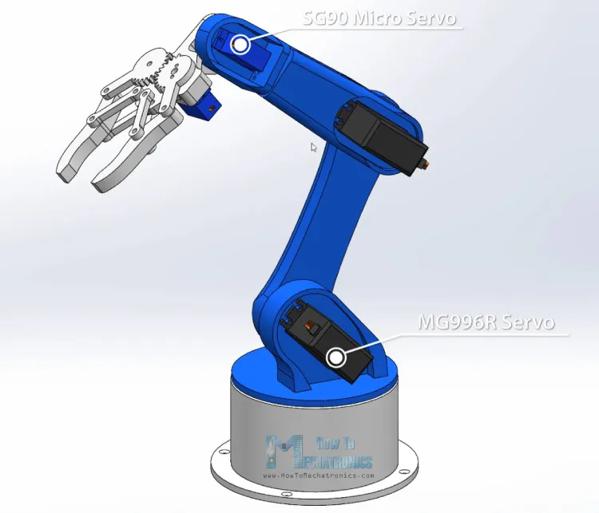

**Block Diagram**

APP USER INTERFACE

PHONE BLUETOOTH

ARDUINO BLUETOOTH RECEIVER

SERVO MOTOR

ARDUINO CHIP

*Block diagram of robot arm using Arduino*

**Circuit Diagram**

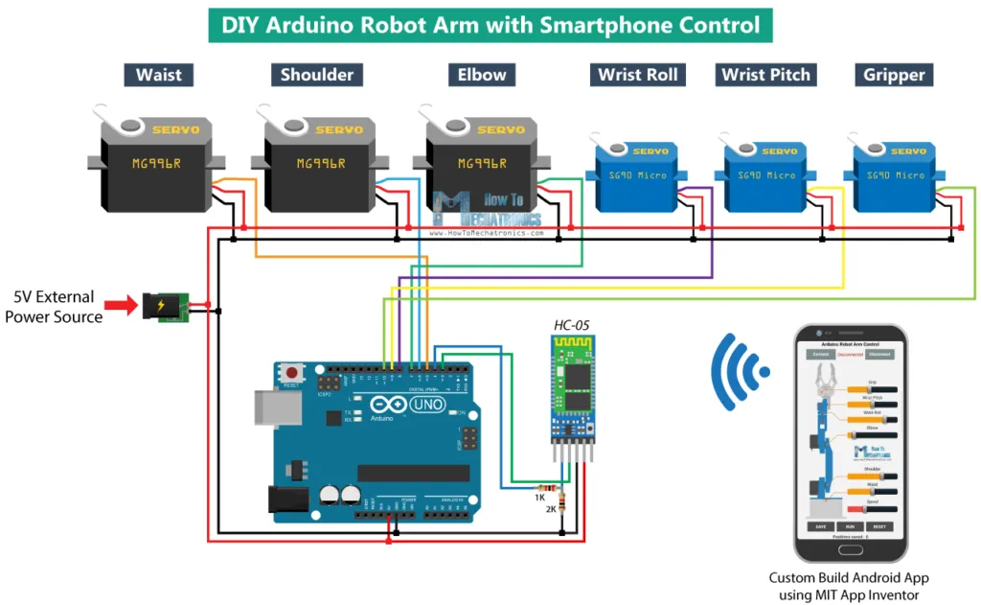

*Circuit diagram*

# Components required

|  |  |
| --- | --- |
| Components | Cost (in Rs.) |
| MG996R Servo Motor -3 | 400/- |
| SG90 Micro Servo Motor-3 | 250/- |
| HC-05 Bluetooth Module | 369/- |
| Arduino Board | 1000/- |
| 5V 2A DC Power Supply | 50/- |
| Total | 2069/- |

# 3-D printer was provided by our department itself for printing all the 3-D components.

# Approximate cost for this project is goes around Rs.2069/-

# THEORETICAL INFRASTRUCTURE

The theoretical background of the project is examined below as main headings and subheadings.

# Arduino UNO Microcontroller

Arduino UNO is an open-source microcontroller word based on the microchip ATmega328P microcontroller and developed by Arduino cc. It has 14 digital input/output pins (of which 6 can be used as PWM outputs), 6 analog inputs

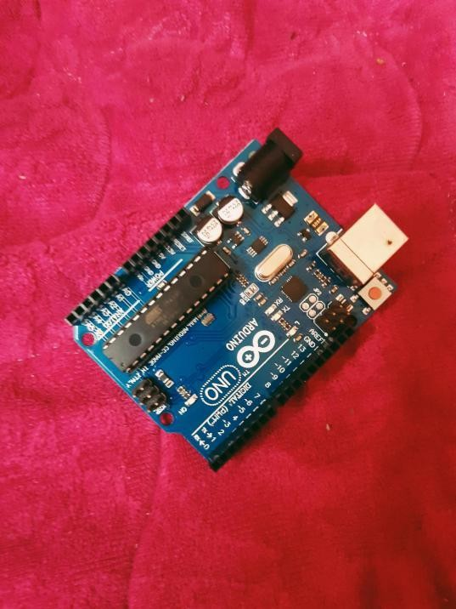

*Arduino UNO Microcontroller use*

# HC- 05 Bluetooth Module

This is a module which can add two-way wireless functionality to your projects. It is used to communicate between microcontrollers or communicate with any device with Bluetooth functionality. This is considered as the perfect choice if you are looking for a wireless module that could transfer data from your computer or mobile phone to a microcontroller or vice versa.

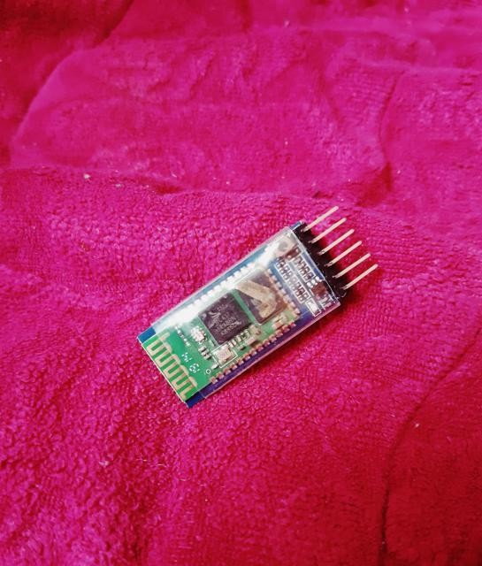

*Figure4. HC- 05 Bluetooth Module*

# Power

A power supply takes the AC from the AC source then produces a DC output of 2A and 5V. The power supply chosen to supply the servomotors’ control circuit is capable of supplying the same current even though all though all the synchronous servomotors are working

**Projected Method**

A research on possible designs and basic information about the robotic arm was initially made. Using Solidworks – a software used for planning, visual ideation, and feasibility assessment, in finalizing the design. Using 6 servo motors, the robotic arm could move in different directions and could hold or release things with its gripper. For the optimal control of the robotic arm, the microcontroller Arduino UNO is used. This microcontroller was preferably used since it is low cost and good for beginners especially in writing the program. The program code was written in c+ + language which is one of the most popular and fundamental programming languages. We also created a mobile application that will be connected to the microcontroller Arduino UNO via Bluetooth module. Controlling the robotic arm will be possible by using the mobile application.

# Designing of Robot Arm

***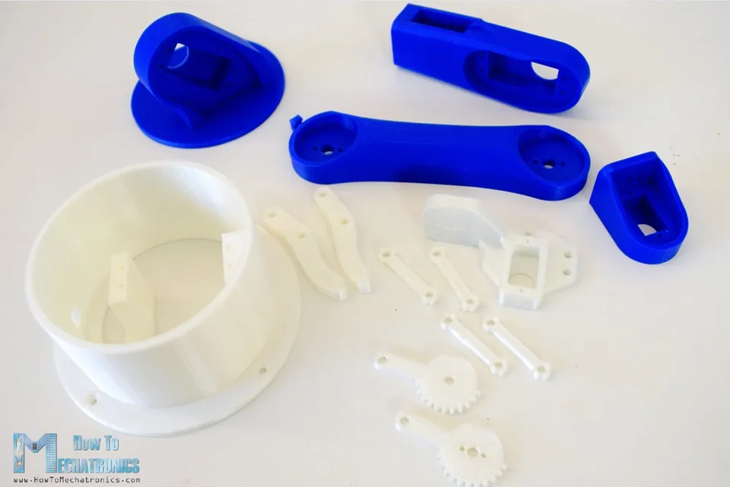*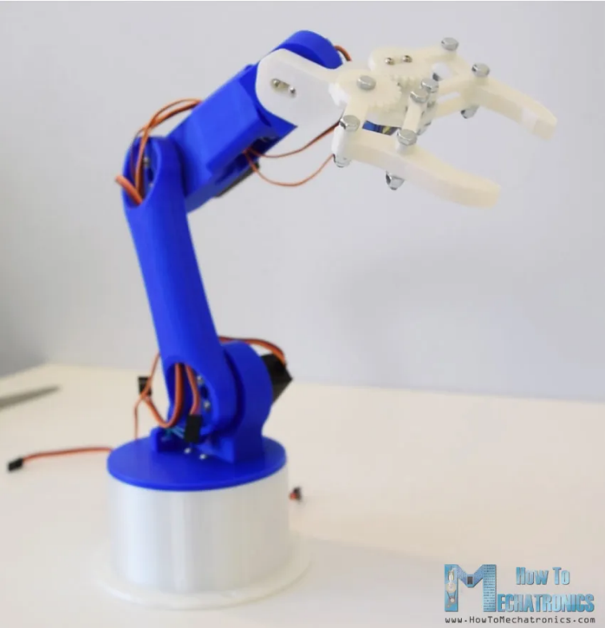**

# Operational of Robot Arm

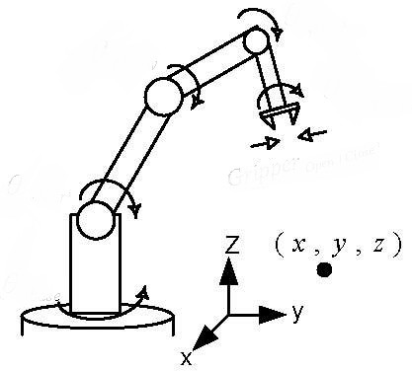The workplace of the robot arm is illustrated in Figure. For this project the robot arm has 5-DOF

|  |  |  |
| --- | --- | --- |
| **No.** | **Servo Part** | **Maximum Angle(°)** |
| 1 | Waist | 180 |
| 2 | Shoulder | 60 |
| 3 | Elbow | 85 |
| 4 | Wrist Roll | 180 |
| 5 | Wrist Pitch | 180 |
| 6 | Grip | 90 |

**Design of the Android Application**

*(c)*

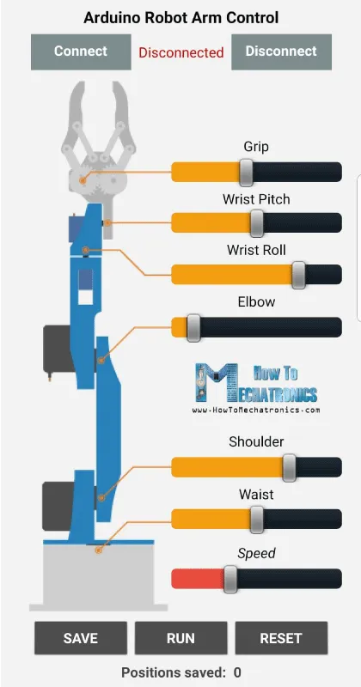

-: THANK YOU :-